ATTAIN ALI – Steps to Adding Workstations and Monitors

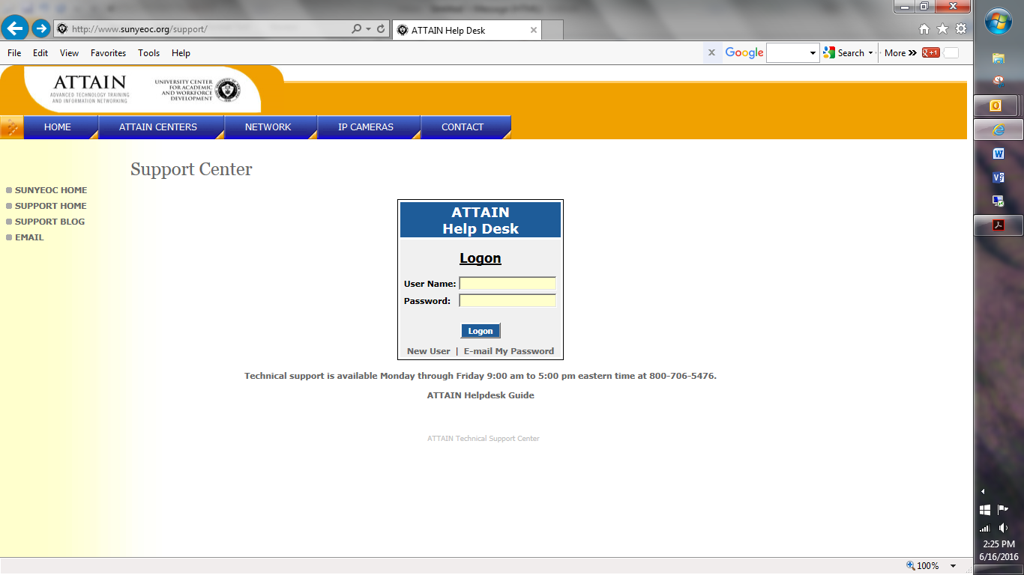

<http://www.sunyeoc.org/support/>

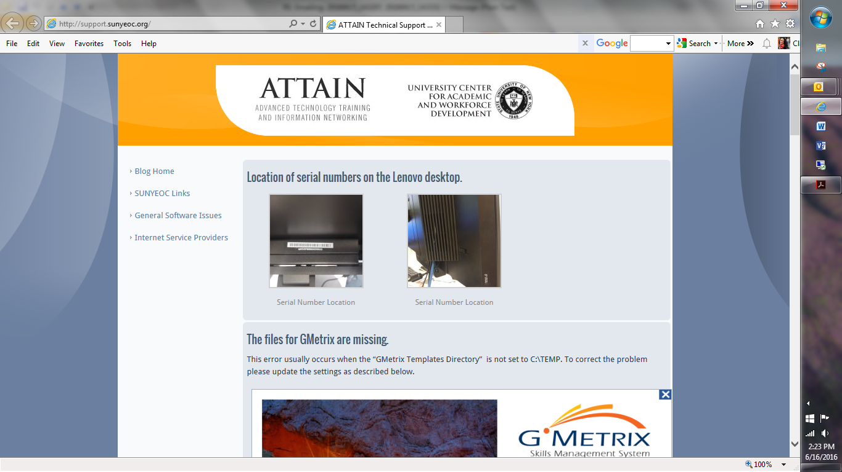

Location of Model/Type and Serial numbers

<http://support.sunyeoc.org/>

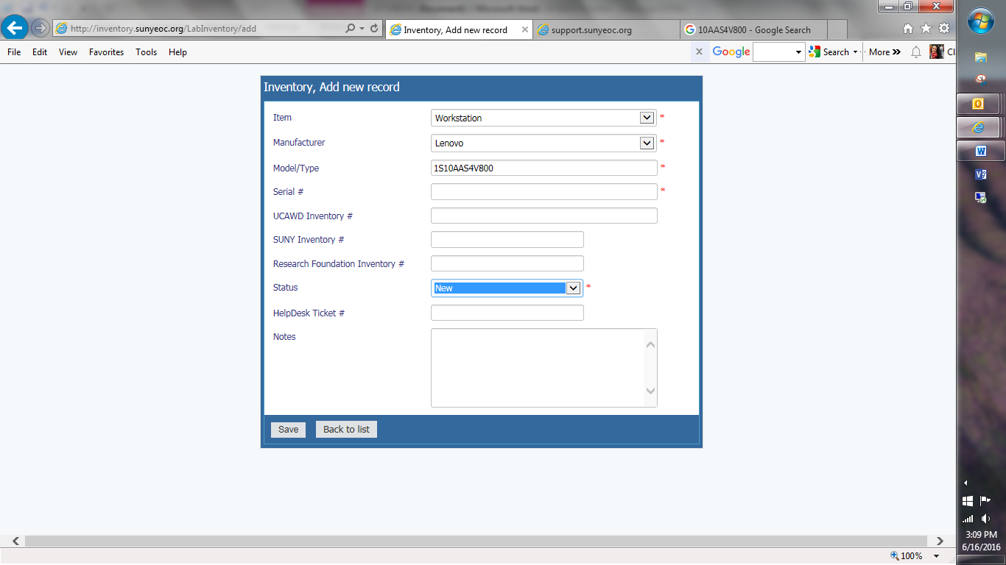

Select Workstation or Monitor

Select Manufacturer: Lenovo

Model/Type: for a workstation this is Lenovo’s pattern - 1S10AA/S4V800

\*please verify – exact number may be different for each site\*

Serial number – begins with MJ

Status: New

Monitor Model/Type: 10DQ-PAR6-WW

\*please verify – exact number may be different for each site\*

Repeat for each workstation and monitor