Overview: These are detailed instructions for setting up SQL Server Express 2012 with SSMS (SQL Server Management Studio) using SA Authentication. The program itself is free. Total installation takes over an hour. Read all the instructions before attempting. IF YOU HAVE PROBLEMS, PLEASE WRITE DOWN DETAILS/SAVE SCREEN SHOTS.

First, log in as Administrator for the installation. You’ll need to identify if you have a 32 or 64 bit system.
Go to Start Button, Control Panel
Select small icon from the Category Dropdown. Select System. Your screen should appear as below:

Go to www.microsoft.com/express/database
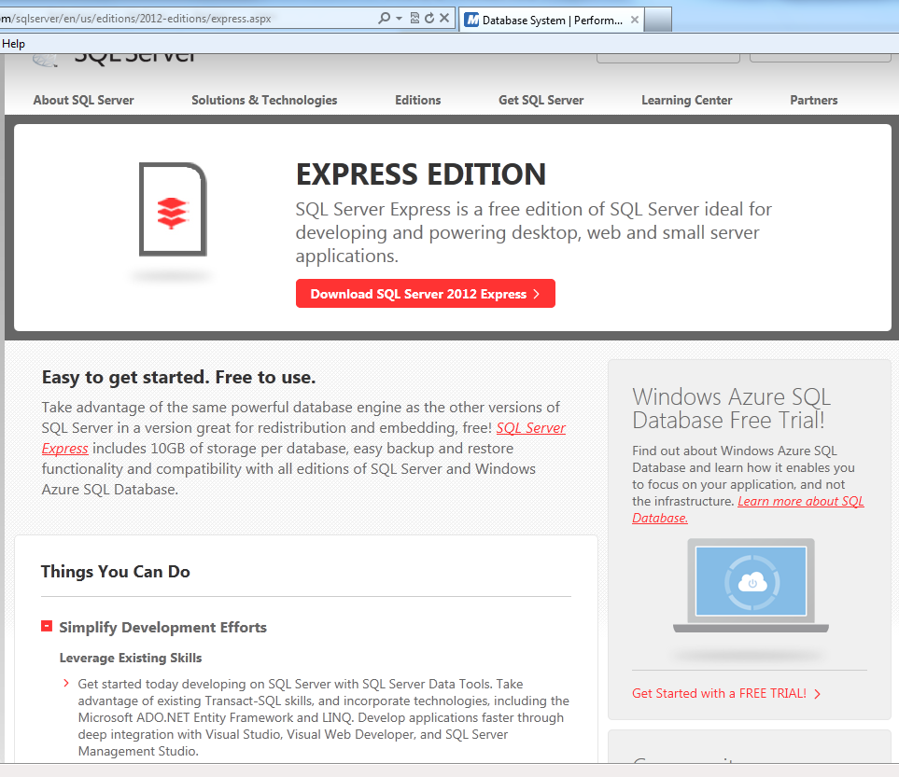
Click here.
Click here.
Pick 32 or 64 Bit English and Express with Tools; Click Download Button

WARNING: Automatic installations take a long time. Be patient. Wait for the next screen to appear. These instructions DO NOT include the numerous installation information boxes that will appear throughout the installation. Only those dialog boxes requiring YOUR INPUT are included in this instruction packet.

GO TO THE NEXT PAGE…

At this point, you may be asked to download Active X and/or Java Applet. (Read red banner at top). An action box will appear prompting you to do so, if those applets are not already installed. Next, you’ll need to install the Download Manager. SCROLL DOWN TO THE BOTTOM OF THE SCREEN FOR THE DOWNLOAD MANAGER.

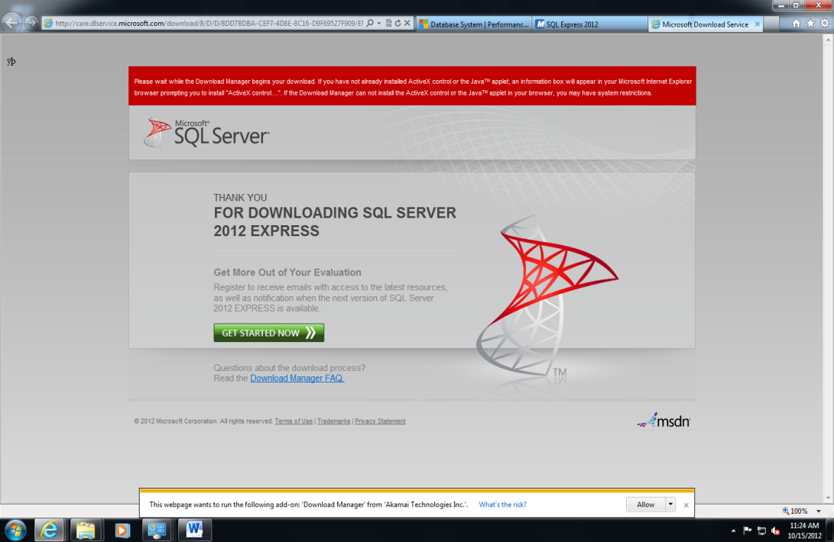
Download Manager. Click Allow. MAY NEED TO SCROLL DOWN TO SEE.
Active X message: If needed, prompt for installation will appear.
Click Install for the Download Manager.

GO TO THE NEXT PAGE…

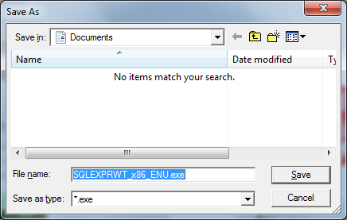
Save Download of Download Manager in the Default location with the Default name. A grey-green arrow icon should appear in the status bar.

The next screen enables both a download and an extraction of the Installation file. The entire process takes approximately 20 minutes. A Dropbox icon should appear on the status bar.
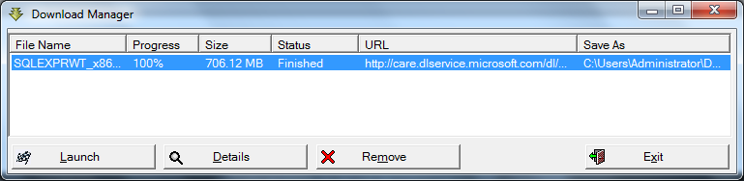

When this screen first pops up, the first button will read Pause. Wait approx. 12 minutes for the SAME button to change to Launch. Click the Launch button ONCE to launch the extraction. May need to re-select SQLEXPRWT file in Download Manager.

BE PATIENT! Wait at least 10 minutes for this dialog box to appear. When it does appear, click first Install Option.

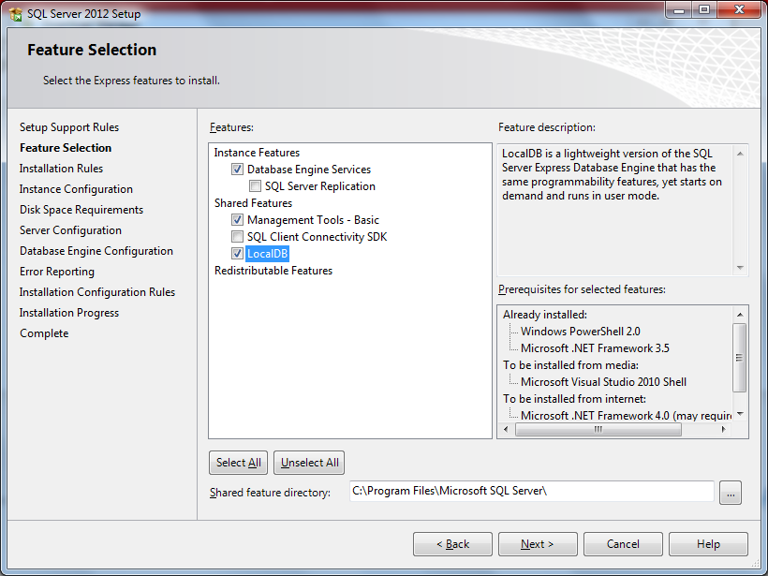
Match Settings.
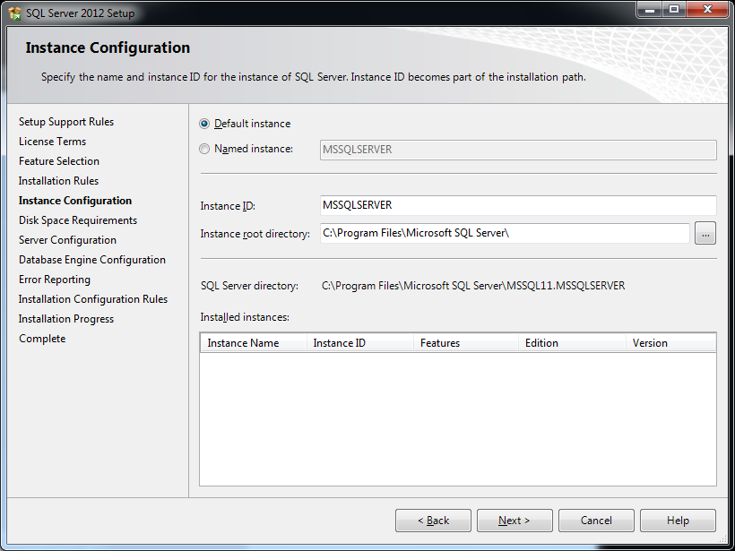

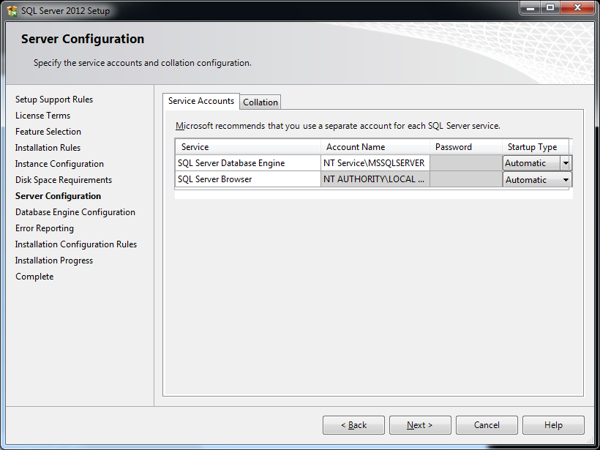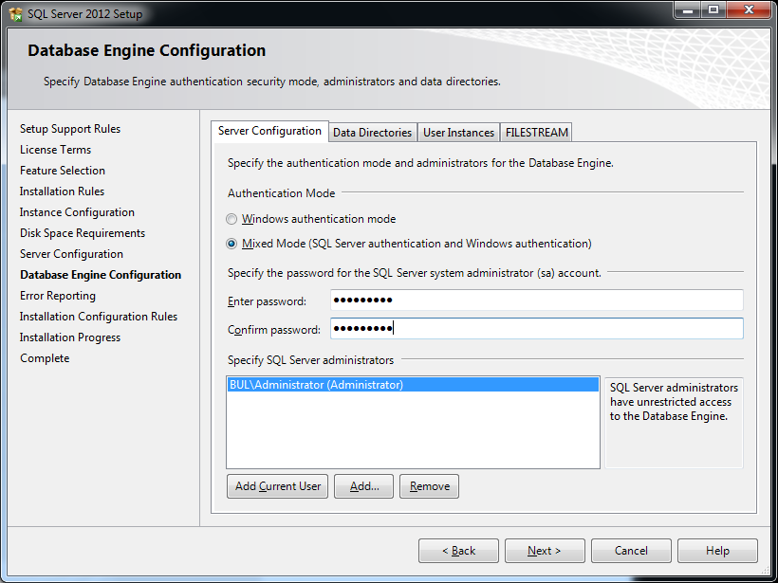
Match Settings
Click
WRITE DOWN PASSWORD!!! Password must have at least 7 characters total; and contain at least one letter, one number, and one symbol.

An Error Reporting Screen will pop up next. Just press next.
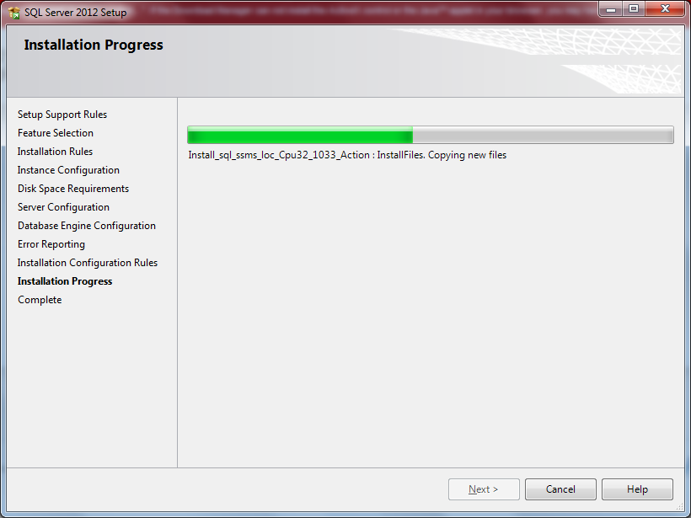
The actual installation takes 45 minutes!
Now, you need to test to make sure it is properly installed.
- Go to the Start Menu, All Programs
- Open the folder Microsoft SQL Server 2012
- Open SQL Server Management Studio (SSMS)
WAIT – it may be slow to start up.
- Eventually, the SSMS Window will appear. The Object Explorer pane should appear on the left-hand side. If not, press F8 or View, Object Explorer.
- An action box will appear asking for your password information. See screenshots on the following page.
- Click New Query in the Toolbar.
- The Query window will appear in middle of the screen. Type the following:
CREATE DATABASE tryme
- Click Execute in the Toolbar.
- Watch the bottom of the Query pane. It should read “Command(s) completed successfully”.
- If not, write down the error message or save a screen shot.

You’ve now tested it under Administrator. Running SSMS under Administrator is okay for a Train the Trainer session (just make sure you switch back to Global afterwards); but, for security’s sake, the program should also run under Global.

Now, Switch to Global, and repeat the above steps. Austine at ISI has modified your server to allow SSMS to run under Global.

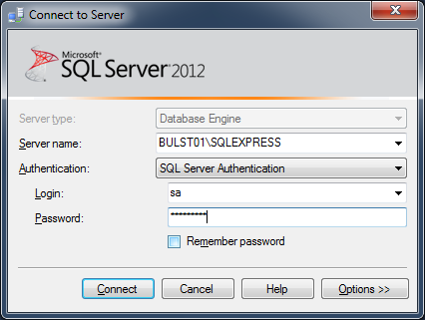
Add your Password

